**DAILY ONLINE ACTIVITIES SUMMARY**

|  |  |  |  |  |  |  |  |  |
| --- | --- | --- | --- | --- | --- | --- | --- | --- |
| **Date:** | **01-07-2020** | | | | | **Name:** | **Huda Sultana** | |
| **Sem & Sec** | **8 A** | | | | | **USN:** | **4AL16CS039** | |
| **Online Test Summary** | | | | | | | | |
| **Subject** | | **-** | | | | | | |
| **Max. Marks** | | **-** | | **Score** | | | **-** | |
| **Certification Course Summary** | | | | | | | | |
| **Course** | **Introduction to AWS Batch.** | | | | | | | |
| **Certificate Provider** | | | **AWS** | | **Duration** | | | **30 mins** |
| **Coding Challenges** | | | | | | | | |
| **Problem Statement:**   1. **Write a C Program to digits in a string** | | | | | | | | |
| **Status: Solved** | | | | | | | | |
| **Uploaded the report in Github** | | | | | **Yes** | | | |
| **If yes Repository name** | | | | | **Hudasulltana/online_coding** | | | |
| **Uploaded the report in slack** | | | | | **Yes** | | | |

Online Test Details:

Not Conducted

Certification Course Details:

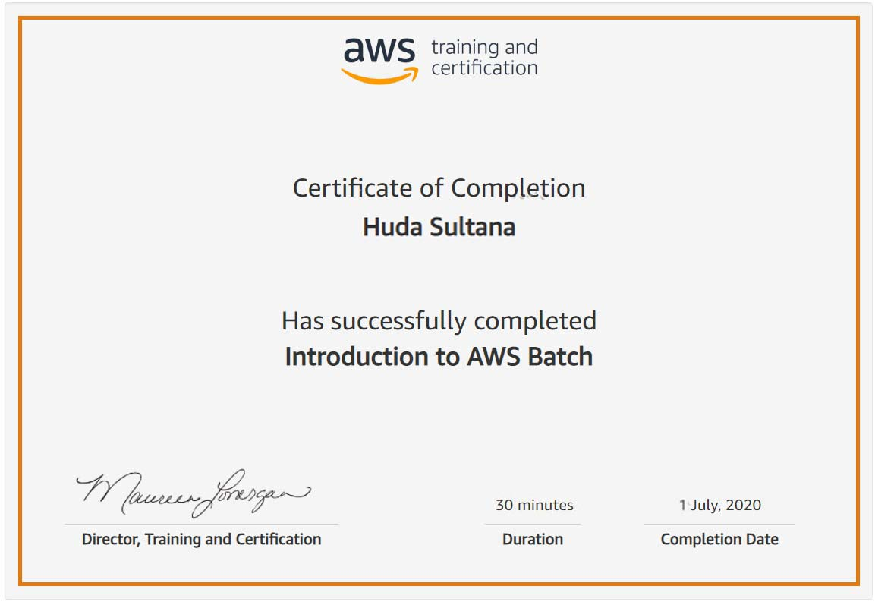

Coding Challenges Details:

**PROGRAM 1 .**

**// digits in a string**

**#include <stdio.h>**

**int main()**

**{**

**char str[80];**

**int count, nc = 0, sum = 0;**

**printf("Enter the string containing both digits and alphabet \n");**

**scanf("%s", str);**

**printf("%s",str);**

**for (count = 0; str[count] != '\0'; count++)**

**{**

**if ((str[count] >= '0') && (str[count] <= '9'))**

**{**

**nc += 1;**

**sum += (str[count] - '0');**

**}**

**}**

**printf("\nNumber of Digits in the string = %d\n", nc);**

**printf("Sum of all digits in the string = %d\n", sum);**

**return 0;**

**}**